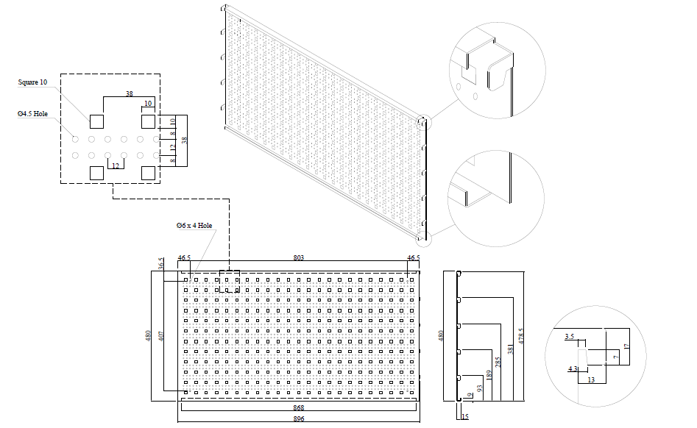
Drawing of tool panels 74100 and 74101, unit: mm

